**ACKNOWLEDGEMENT**

I would like to express my heartfelt gratitude and extend my sincerest appreciation to all those who have contributed to the successful completion of this mini project report.

First and foremost, I would like to thank my mini project guide Prof. M.B. Rangdal & Prof. S.S. Konda, for their valuable guidance, support, and encouragement throughout the entire process. Their expertise, patience, and insightful feedback have been instrumental in shaping this report and enhancing its quality. I am truly grateful for their mentorship and for sharing their knowledge and expertise in the subject matter.

I would also like to express my gratitude to NKOCET-SOLAPUR for providing me with the opportunity to undertake this mini project and for the resources and facilities made available to me. The access to the library, research materials, and databases has been immensely helpful in conducting in-depth research and gathering relevant information for this report.

I am indebted to my colleagues and friends for their continuous support and valuable discussions. Their constructive feedback, brainstorming sessions, and exchange of ideas have played a significant role in refining my understanding of the topic and in shaping the direction of this report.

In conclusion, I would like to express my deepest gratitude to all those mentioned above and to anyone else who has directly or indirectly contributed to this seminar report. Your support, guidance, and encouragement have been indispensable, and I am truly honored and privileged to have had the opportunity to learn and grow through this experience.

Thank you all.

B-04 Karan R. Bharale

B-14 Nilesh N. Deshpande

B-62 Yogesh T. Sutar

**ABSTRACT**

StudyNotion, an innovative ed-tech platform, employs the MERN stack—leveraging ReactJS, NodeJS, MongoDB, and ExpressJS—to deliver a dynamic learning experience. The client-server architecture facilitates seamless interaction, with ReactJS serving as the engaging front end, communicating with the NodeJS and ExpressJS back end, which, in turn, manages data in a MongoDB database. Designed with Figma, the front end accommodates essential pages for students, such as the Homepage, Course List, Wishlist, and more. Instructors benefit from a robust Dashboard, Insights, and Course Management pages. Admin functionalities for future implementation are outlined, ensuring the platform's adaptability and scalability.

The back end, adopting a monolithic architecture, incorporates Node.js, Express.js, and MongoDB. It encompasses features like user authentication, course management, and payment integration via Razorpay. The utilization of Cloudinary for media management and markdown formatting for course content enhances the platform's versatility. Security measures include JWT for authentication and Bcrypt for password hashing. Data models for students, instructors, and courses are defined to manage user information effectively. The RESTful API design, implemented with Node.js and Express.js, fosters seamless communication between the front end and back end, promoting scalability and reliability. Deployment, orchestrated with Vercel or Render, Cloudinary, and MongoDB Atlas, ensures a stable, scalable, and secure hosting environment. Future enhancements, ranging from gamification features to personalized learning paths and mobile app development, position StudyNotion as a forward-thinking platform poised for continuous growth and improvement. Anticipated challenges, including technology integration and debugging, are acknowledged but are met with the project's commitment to overcoming obstacles for the benefit of an enriched user experience.

**INDEX**

|  |  |  |
| --- | --- | --- |
| **Sr. No** | **Title** | **Page. No** |
| 1 | Introduction | 4 |
| 2 | Project Description | 6 |
| 3 | ApplicationDetails | 18 |
| 4 | Technologies | 21 |
| 5 | Advantages & Disadvantages | 26 |
| 6 | Future Scope | 30 |
| 7 | Conclusion | 33 |
| 8 | References | 34 |

**INTRODUCTION**

StudyNotion is an innovative ed-tech platform designed to revolutionize the learning experience for students and instructors alike. Built on the robust MERN stack – incorporating ReactJS, NodeJS, MongoDB, and ExpressJS – StudyNotion aims to make education more accessible and engaging. The platform's overarching goal is to provide a seamless, interactive environment for students while offering instructors a global platform to showcase their expertise.

The system architecture of StudyNotion comprises three main components: the front end, back end, and database, following a client-server model. The front end, developed using ReactJS, facilitates dynamic and responsive user interfaces crucial for an engaging learning experience. The front end communicates with the back end through RESTful API calls, which is built using NodeJS and ExpressJS, ensuring scalability and robustness. MongoDB serves as the NoSQL database, offering flexible and scalable storage for course content and user data.

The front end, essentially the user interface, is meticulously designed using Figma, a popular design tool. The pages cater to both students and instructors, featuring elements like the homepage, course list, wishlist, cart checkout, course content, and user details. Instructors have dedicated pages like the dashboard, insights, and course management, emphasizing a user-centric design approach. CSS, Tailwind, and additional npm packages are utilized for styling, while Redux manages the application's state. Development is facilitated in VSCode, a renowned code editor.

Moving to the back end, StudyNotion adopts a monolithic architecture with Node.js, Express.js, and MongoDB. This architecture ensures better control, security, and performance. The back end boasts features such as user authentication, course management, payment integration through Razorpay, and

cloud-based media management via Cloudinary. Markdown formatting is employed for course content, enhancing display and rendering on the front end. Security is bolstered through JWT for authentication, Bcrypt for password hashing, and Mongoose as an Object Data Modeling library.

The API design follows the REST architectural style, implemented using Node.js and Express.js. Key endpoints include user authentication, course management, and student-instructor interactions. Sample API requests and responses illustrate the seamless communication between the front end and back end.

StudyNotion's deployment process leverages cloud-based services for scalability, security, and reliability. Vercel hosts the front end, Render host the back end, Cloudinary manages media files, and MongoDB Atlas handles the database.

Looking to the future, StudyNotion envisions enhancements such as gamification features, personalized learning paths, social learning elements, a mobile app, machine learning-powered recommendations, and virtual reality/augmented reality integration. These improvements aim to elevate the platform's user engagement, satisfaction, and overall educational experience.

In conclusion, StudyNotion stands as a versatile and intuitive ed-tech platform, meticulously designed to provide an immersive learning experience for students and a global showcase for instructors. This document comprehensively outlines the platform's architecture, features, and deployment process, setting the stage for a transformative journey in education technology.

**PROJECT DESCRIPTION**

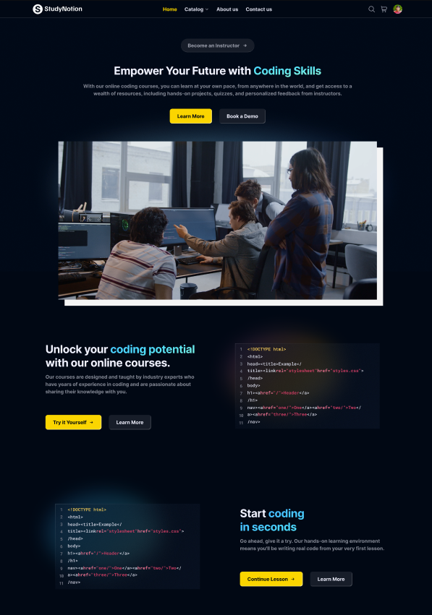

**Fig. 1.1 StudyNotion**

**An ed-tech platform**

StudyNotion is a fully functional ed-tech platform that enables users to create, consume, and rate educational content. The platform is built using the MERN stack, which includes ReactJS, NodeJS, MongoDB, and ExpressJS.

**StudyNotion aims to provide:**

* A seamless and interactive learning experience for students, making education more accessible and engaging.
* A platform for instructors to showcase their expertise and connect with learners across the globe.

In the following sections, we will cover the technical details of the platform, including:

1. System architecture: The high-level overview of the platform's components and diagrams of the architecture.
2. Front-end: The description of the front-end architecture, user interface design, features, and functionalities of the front-end, and frameworks, libraries, and tools used.
3. Back-end: The description of the back-end architecture, features and functionalities of the back-end, frameworks, libraries, tools used, and data models and database schema.
4. API Design: The description of the API design, list of API endpoints, their functionalities, and sample API requests and responses.
5. Deployment: The description of the deployment process, hosting environment and infrastructure, and deployment scripts and configuration.
6. Testing: The description of the testing process, types of testing, test frameworks and tools used.
7. Future Enhancements: The list of potential future enhancements to the platform, explanation of how these enhancements would improve the platform, estimated timeline and priority for implementing these enhancements.

In summary, StudyNotion is a versatile and intuitive ed-tech platform that is designed to provide an immersive learning experience to students and a platform for instructors to showcase their expertise. In the following sections, we will delve into the technical details of the platform, which will provide a comprehensive understanding of the platform's features and functionalities.

# System Architecture

The StudyNotion ed-tech platform consists of three main components: the front end, the back end, and the database. The platform follows a client-server architecture, with the front end serving as the client and the back end and database serving as the server.

### Front-end

The front end of the platform is built using ReactJS, which is a popular JavaScript library for building user interfaces. ReactJS allows for the creation of dynamic and responsive user interfaces, which are critical for providing an engaging learning experience to the students. The front end communicates with the back end using RESTful API calls.

### Back-end

The back end of the platform is built using NodeJS and ExpressJS, which are popular frameworks for building scalable and robust server-side applications. The back end provides APIs for the front end to consume, which include functionalities such as user authentication, course creation, and course consumption. The back end also handles the logic for processing and storing the course content and user data.

### Database

The database for the platform is built using MongoDB, which is a NoSQL database that provides a flexible and scalable data storage solution. MongoDB allows for the storage of unstructured and semi-structured data, which is useful for storing course content such as videos, images, and PDFs. The database stores the course content, user data, and other relevant information related to the platform.

### Architecture Diagram

Here is a high-level diagram that illustrates the architecture of the StudyNotion ed-tech platform:

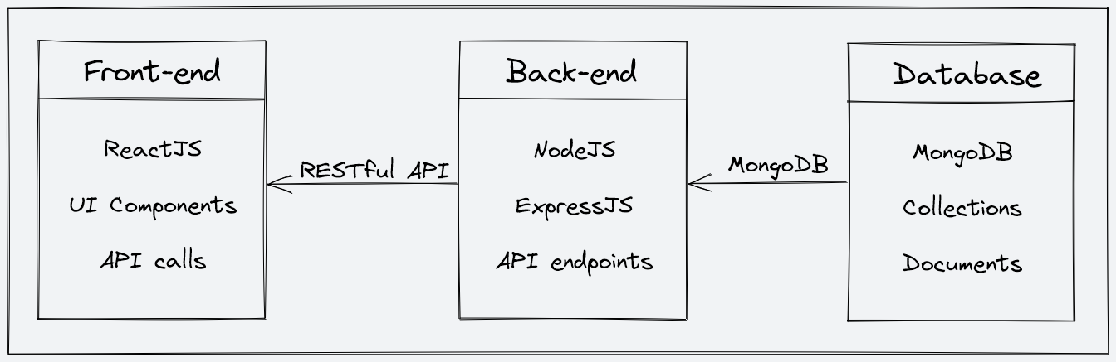

### Fig. 2.1 Architecture Diagram

# Front-end

The front end is part of the platform that the user interacts with. It's like the "face" of the platform that the user sees and interacts with. The front end of StudyNotion is designed using a tool called Figma, which is a popular design tool that allows for the creation of clean and minimal user interfaces. You can take a look at the Figma design for the StudyNotion front-end by following this link: <https://www.figma.com/file/Mikd0FjHKAofUlWQSi70nf/StudyNotion_shared>.

The front end of StudyNotion has all the necessary pages that an ed-tech platform should have. Some of these pages are:

#### For Students:

* Homepage: This page will have a brief introduction to the platform, as well as links to the course list and user details.
* Course List: This page will have a list of all the courses available on the platform, along with their descriptions and ratings.
* Wishlist: This page will display all the courses that a student has added to their wishlist.
* Cart Checkout: This page will allow the user to complete the course purchase.
* Course Content: This page will have the course content for a particular course, including videos, and other related material.
* User Details: This page will have details about the student's account, including their name, email, and other relevant information.
* 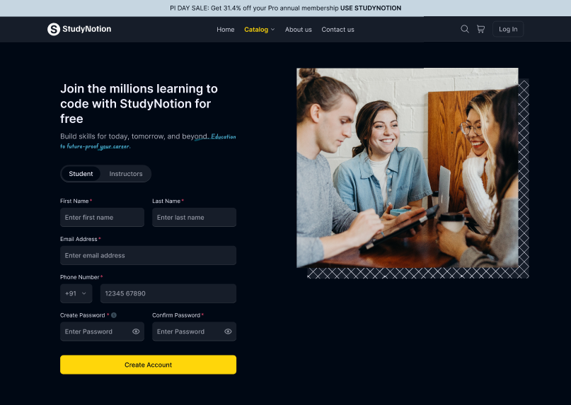User Edit Details: This page will allow the student to edit their account details.

Fig. 3.1 Student Signup Page.

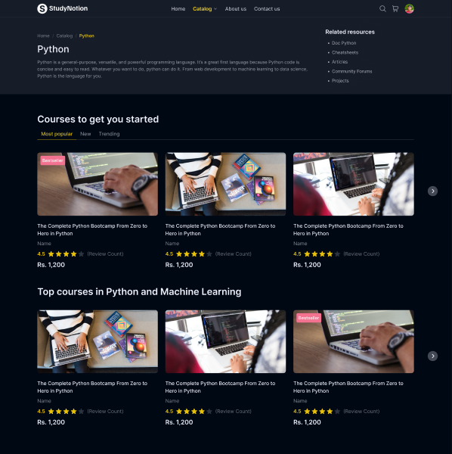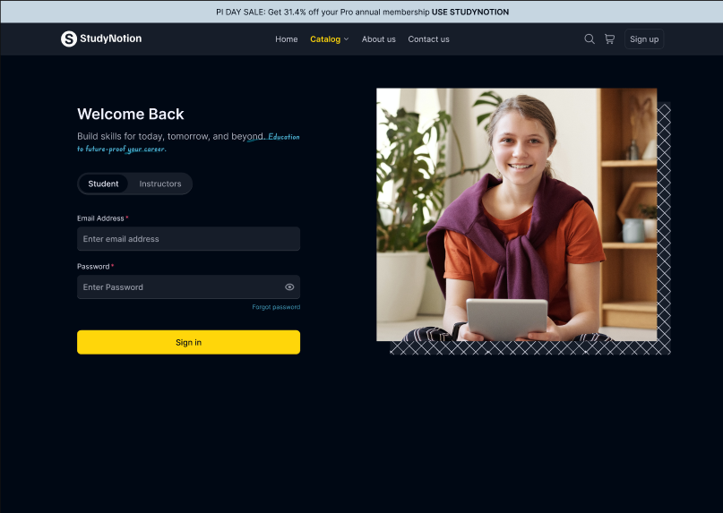

Fig. 3.3 Courses Page.

Fig. 3.2 Student Login Page.

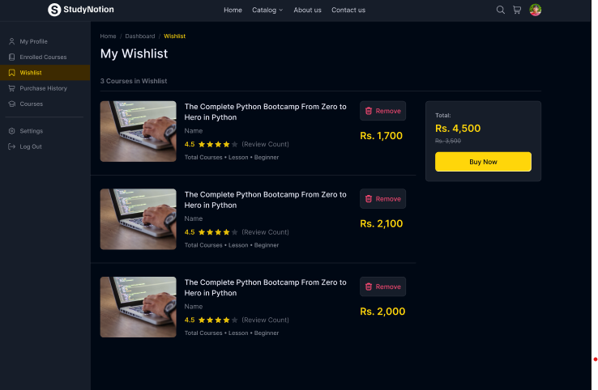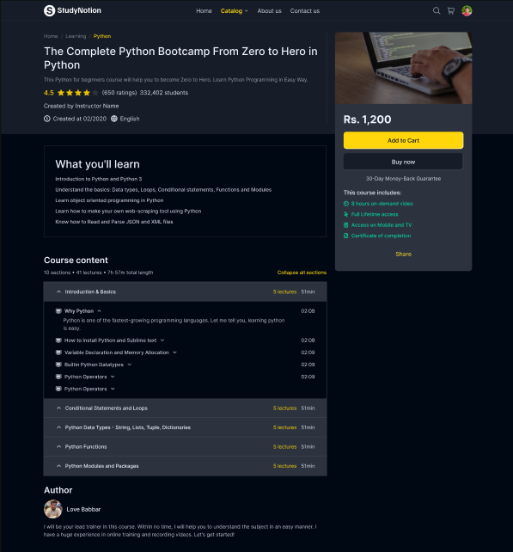

Fig. 3.4 Course Description Page.

Fig.3.5 Wishlist Page.

#### For Instructors:

* Dashboard: This page will have an overview of the instructor's courses, as well as the ratings and feedback for each course.
* Insights: This page will have detailed insights into the instructor's courses, including the number of views, clicks, and other relevant metrics.
* Course Management Pages: These pages will allow the instructor to create, update, and delete courses, as well as manage the course content and pricing.
* View and Edit Profile Details: These pages will allow the instructor to view and edit their account details.

Fig. 4.1 Instructors Signup Page.



Fig. 4.2 Instructors Login Page.

To build the front end, we use frameworks and libraries such as ReactJS, which is a popular JavaScript library for building user interfaces. We also use CSS and Tailwind, which are styling frameworks that help make the user interface look good and responsive. Additionally, we use some npm packages to add extra functionality to the front end. To manage the state of the application, we use Redux, which is a popular state management library for React. Finally, we use a development environment called VSCode, which is a popular code editor, to develop the front end.

# Back-end

### Description of the Back-end Architecture:

StudyNotion uses a monolithic architecture, with the backend built using Node.js and Express.js, and MongoDB as the primary database. Monolithic architecture refers to a design approach where all the modules of the application are combined into a single large program, with a single codebase, to enable better control, security, and performance.

Node.js is a popular JavaScript runtime that allows us to run JavaScript code outside of the browser. Express.js is a web application framework that simplifies the process of building web applications in Node.js. MongoDB is a popular NoSQL database that allows for flexible data storage and retrieval, making it a suitable choice for complex applications like StudyNotion.

### Features and Functionalities of the Back-end:

The back end of StudyNotion provides a range of features and functionalities, including:

1. User authentication and authorization: Students and instructors can sign up and log in to the platform using their email addresses and password. The platform also supports OTP (One-Time Password) verification and forgot password functionality for added security.
2. Course management: Instructors can create, read, update, and delete courses, as well as manage course content and media. Students can view and rate courses.
3. Payment Integration: Students will purchase and enrol on courses by completing the checkout flow that is followed by Razorpay integration for payment handling.
4. Cloud-based media management: StudyNotion uses Cloudinary, a cloud-based media management service, to store and manage all media content, including images, videos, and documents.
5. Markdown formatting: Course content in document format is stored in Markdown format, which allows for easier display and rendering on the front end.

### Frameworks, Libraries, and Tools used:

The back end of StudyNotion uses a range of frameworks, libraries, and tools to ensure its functionality and performance, including:

1. Node.js: Node.js is used as the primary framework for the back end.
2. MongoDB: MongoDB is used as the primary database, providing a flexible and scalable data storage solution.
3. Express.js: Express.js is used as a web application framework, providing a range of features and tools for building web applications.
4. JWT: JWT (JSON Web Tokens) are used for authentication and authorization, providing a secure and reliable way to manage user credentials.
5. Bcrypt: Bcrypt is used for password hashing, adding an extra layer of security to user data.
6. Mongoose: Mongoose is used as an Object Data Modeling (ODM) library, providing a way to interact with MongoDB using JavaScript.

### Data Models and Database Schema:

The back end of StudyNotion uses a range of data models and database schemas to manage data, including:

1. Student schema: Includes fields such as name, email, password, and course details for each student.
2. Instructor schema: Includes fields such as name, email, password, and course details for each instructor.
3. Course schema: Includes fields such as course name, description, instructor details, and media content.

Overall, the back-end of StudyNotion is designed to provide a robust and scalable solution for an ed-tech platform, with a focus on security, reliability, and ease of use. By using the right frameworks, libraries, and tools, we can ensure that the platform functions smoothly and provides an optimal user experience for all its users.

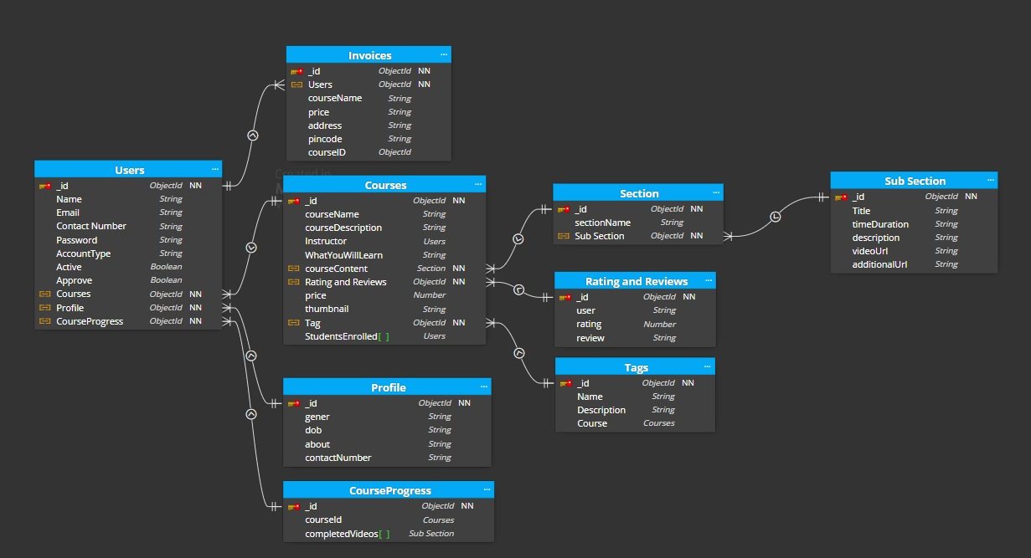

Fig. 5.1 Data Models and Database Schema.

**APPLICATION DETAILS**

Application Details for StudyNotion Ed-Tech Platform

**1. Overview:**

- Name: StudyNotion Ed-Tech Platform

- Version: 1.0

- Description: A versatile and intuitive educational technology platform designed to offer a seamless and interactive learning experience for students while providing a platform for instructors to showcase their expertise. Built using the MERN stack (MongoDB, ExpressJS, ReactJS, NodeJS), StudyNotion facilitates the creation, consumption, and rating of educational content.

**2. System Architecture:**

- Components: Front-end, Back-end, Database

- Architecture Type: Client-Server

- Technologies Used: ReactJS, NodeJS, ExpressJS, MongoDB

**3. Front-end:**

- Tools and Frameworks: ReactJS, Figma, CSS, Tailwind, Redux, VSCode

- User Pages: Homepage, Course List, Wishlist, Cart Checkout, Course Content, User Details, User Edit Details (For Students); Dashboard, Insights, Course Management, View and Edit Profile Details (For Instructors); Dashboard, Insights, Instructor Management (For Admin - Future Scope)

**4. Back-end:**

- Architecture Type: Monolithic

- Technologies Used: Node.js, Express.js, MongoDB

- Features: User authentication, Course management, Payment integration, Cloud-based media management, Markdown formatting

- Security: JWT for authentication, Bcrypt for password hashing

- Database Models: Student, Instructor, Course

**5. API Design:**

- Architecture Style: RESTful

- Implemented Using: Node.js, Express.js

- Endpoints: /api/auth/signup, /api/auth/login, /api/auth/verify-otp, /api/auth/forgot-password, /api/courses, /api/courses/:id, /api/courses (POST), /api/courses/:id (PUT), /api/courses/:id (DELETE), /api/courses/:id/rate (POST)

- Data Exchange Format: JSON

- Sample Requests and Responses Provided

**6. Deployment:**

- Front-end Hosting: Vercel

- Back-end Hosting: Render

- Media Hosting: Cloudinary

- Database Hosting: MongoDB Atlas

- Benefits: Scalability, Security, Reliability

**7. Testing:**

- Types of Testing: Unit Testing, Integration Testing, End-to-End Testing

**8. Future Enhancements:**

- Gamification Features: Medium Priority

- Personalized Learning Paths: High Priority

- Social Learning Features: Medium Priority

- Mobile App: High Priority

- Machine Learning Recommendations: Medium to High Priority

- VR/AR Integration: Low to Medium Priority

**9. Conclusion:**

- Achievements: Implementation of MERN stack, REST API design, Deployment on cloud services

- Challenges: Integration of technologies, Debugging errors

**10. Timeline:**

- Start Date: May 2023

- Estimated Completion Date: August 2023

**11. Project Team:**

- B-04 Karan Rajanna Bharale

- B-14 Nilesh Nagraj Deshpande

- B-62 Yogesh Tukaram Sutar

This application details document provides a comprehensive overview of the StudyNotion Ed-Tech Platform, encompassing its architecture, features, deployment, testing, future enhancements, and contact information.

**TECHNOLOGIES**

**System Architecture:**

The StudyNotion ed-tech platform follows a client-server architecture, comprising the front end, back end, and a MongoDB database. The system architecture ensures a seamless flow of data and interactions between these components.

**Front-end Technologies:**

**ReactJS:** StudyNotion's front end is developed using ReactJS, a powerful JavaScript library for building dynamic and responsive user interfaces. ReactJS facilitates the creation of engaging and interactive learning experiences.

**Figma:** The front-end design is crafted using Figma, a popular design tool, ensuring a clean and minimalistic user interface. The Figma design can be viewed [here](<https://www.figma.com/file/Mikd0FjHKAofUlWQSi70nf/StudyNotion_shared?type=design&node-id=0-1&mode=design>).

**CSS and Tailwind:** Styling frameworks such as CSS and Tailwind are employed to enhance the visual appeal of the user interface, making it aesthetically pleasing and responsive.

**Redux:** For state management in the application, Redux, a widely-used state management library for React, is utilized. It helps in maintaining a consistent and efficient state across the application.

**VSCode:** Visual Studio Code serves as the primary development environment, providing a robust code editing platform for front-end development.

**Back-end Technologies:**

NodeJS and ExpressJS: The back end is built on the NodeJS runtime and ExpressJS framework, ensuring scalability and robustness for server-side operations. ExpressJS simplifies the development of web applications in NodeJS.

**MongoDB:** As the primary database, StudyNotion uses MongoDB, a NoSQL database known for its flexibility and scalability in handling unstructured and semi-structured data.

**Cloudinary:** Cloudinary, a cloud-based media management service, is integrated into StudyNotion for efficient storage and management of media content, including images, videos, and documents.

**JWT (JSON Web Tokens):** JWT is employed for secure and reliable user authentication and authorization, providing a token-based authentication mechanism.

**Bcrypt:** Bcrypt is utilized for password hashing, adding an additional layer of security to user data.

**Mongoose:** Mongoose serves as the Object Data Modeling (ODM) library, facilitating interaction with MongoDB using JavaScript.

**Database Schema:**

StudyNotion's back end utilizes various data models and database schemas:

**- Student Schema:** Includes fields such as name, email, password, and course details for each student.

**- Instructor Schema:** Contains fields like name, email, password, and course details for each instructor.

**- Course Schema**: Encompasses fields such as course name, description, instructor details, and media content.

**API Design:**

The StudyNotion platform's API adheres to the REST architectural style, implemented using Node.js and Express.js. Key API endpoints and their functionalities include:

- `/api/auth/signup (POST)`: Create a new user account (student or instructor).

- `/api/auth/login (POST)`: Log in using existing credentials and generate a JWT token.

- `/api/auth/verify-otp (POST)`: Verify the OTP sent to the user's registered email.

- `/api/auth/forgot-password (POST)`: Send an email with a password reset link to the registered email.

- `/api/courses (GET)`: Get a list of all available courses.

- `/api/courses/:id (GET)`: Get details of a specific course by ID.

- `/api/courses (POST)`: Create a new course.

- `/api/courses/:id (PUT)`: Update an existing course by ID.

- `/api/courses/:id (DELETE)`: Delete a course by ID.

- `/api/courses/:id/rate (POST)`: Add a rating (out of 5) to a course.

**Sample API Requests and Responses:**

- `GET /api/courses`: Retrieve a list of all courses.

- Response: A list of all courses in the database.

- `GET /api/courses/:id`: Retrieve a single course by ID.

- Response: The course with the specified ID.

- `POST /api/courses`: Create a new course.

- Request: Course details in the request body.

- Response: The newly created course.

- `PUT /api/courses/:id`: Update an existing course by ID.

- Request: Updated course details in the request body.

- Response: The updated course.

- `DELETE /api/courses/:id`: Delete a course by ID.

- Response: A success message indicating the course has been deleted.

**Deployment:**

The deployment process involves hosting on various cloud-based services:

**- Front End (Vercel):** Hosted on Vercel, a popular service for static sites built with React.

**- Back End (Render):** Hosted on Render.com, cloud-based services for Node.js applications with MongoDB.

**- Media Files (Cloudinary):** Cloudinary hosts and manages all media content, ensuring reliable storage with optimization features.

**- Database (MongoDB Atlas):** MongoDB Atlas is used for hosting the database, providing a highly available and secure environment.

**Future Enhancements:**

StudyNotion envisions several future enhancements to improve the platform:

**1. Gamification Features (Medium Priority):** Introduce badges, points, and leaderboards for increased user engagement and motivation.

**2. Personalized Learning Paths (High Priority):** Implement personalized learning paths based on student interests and learning styles to enhance satisfaction and success.

**3. Social Learning Features (Medium Priority**): Add group discussions, peer-to-peer feedback, and collaborative projects to boost student engagement and interaction.

**4. Mobile App (High Priority):** Develop a mobile app for convenient access to course content, expanding the platform's reach.

**5. Machine Learning-Powered Recommendations (Medium to High Priority):** Use machine learning algorithms to offer personalized course recommendations, improving student engagement.

**6. Virtual Reality/Augmented Reality Integration (Low to Medium Priority):** Enhance the learning experience by incorporating virtual reality or augmented reality components into certain courses.

The StudyNotion ed-tech platform, built on the MERN stack, aims to provide a comprehensive and engaging learning experience. The detailed architecture, technologies, and future enhancements outlined in this report showcase the platform's commitment to versatility, security, and continuous improvement. As development progresses, challenges will be addressed, and milestones achieved in creating a user-friendly and innovative educational platform.

**ADVANTAGES & DISADVANTAGES**

**Advantages:**

**1. Comprehensive Learning Experience:** StudyNotion provides a comprehensive learning experience for students by offering features like course lists, wishlists, and interactive course content. This promotes effective learning and engagement.

**2. Global Instructor Connectivity:** The platform serves as a global hub for instructors to showcase their expertise. This facilitates global connectivity between instructors and learners, creating a diverse and enriched learning environment.

**3. MERN Stack Technology:** The use of the MERN stack (MongoDB, Express.js, ReactJS, NodeJS) ensures a cohesive and efficient development process. These technologies are well-integrated, allowing for seamless communication between the front end, back end, and database.

**4. Responsive User Interface:** The front-end design using ReactJS and the Figma tool ensures a responsive and visually appealing user interface. Tailwind and CSS further contribute to a polished and user-friendly design.

**5. Scalable and Robust Back-End:** The back-end, built with NodeJS and ExpressJS, is designed to be scalable and robust. It provides essential functionalities such as user authentication, course management, and payment integration.

**6. Flexible Database with MongoDB:** MongoDB, as a NoSQL database, offers flexibility in storing unstructured and semi-structured data, making it suitable for diverse course content, including videos, images, and documents.

**7. RESTful API Design:** The RESTful API design using Node.js and Express.js ensures efficient communication between the front end and back end. It follows standard HTTP methods, promoting scalability and maintainability.

**8. Secure User Authentication:** The platform incorporates secure user authentication with features like JWT for token-based authentication and Bcrypt for password hashing, enhancing the overall security of user data.

**9. Cloud-Based Media Management:** Integration of Cloudinary for media management provides a scalable solution for storing and handling images, videos, and documents associated with course content.

**10. Deployment on Reliable Cloud Services: Hosting** on Vercel for the front end, Render for the back end, Cloudinary for media files, and MongoDB Atlas for the database ensures a reliable and scalable hosting environment.

**11. Potential for Future Enhancements:** The platform has a roadmap for future enhancements, including gamification features, personalized learning paths, social learning features, a mobile app, machine learning-powered recommendations, and virtual reality/augmented reality integration.

**Disadvantages:**

**1. Monolithic Architecture:** The use of a monolithic architecture may pose challenges in terms of scalability as the application grows. Microservices architecture could be considered for better scalability and maintenance.

**2. Learning Curve for New Technologies:** Users, especially instructors and administrators, may face a learning curve when adapting to new technologies and tools integrated into the platform, such as Figma for design or specific npm packages.

**3. Resource Intensive:** Implementing features like virtual reality/augmented reality may require significant resources, both in terms of development efforts and hardware capabilities, potentially limiting accessibility for certain users.

**4. Limited Admin Functionalities:** The description of admin functionalities is brief, and the platform may benefit from more detailed features and tools for admin management and analytics.

**5. Dependency on External Services:** The reliance on external services like Cloudinary, Vercel, Render, and MongoDB Atlas may introduce dependencies and potential points of failure beyond the project's direct control.

**6. Potential Security Concerns:** While the document mentions secure user authentication practices, the overall security measures implemented in the system, especially against potential cyber threats, should be continuously monitored and updated.

**7. Balancing Priorities in Future Enhancements:** Determining the priority and timeline for implementing future enhancements may be challenging, requiring

careful consideration of user needs, technological feasibility, and resource availability.

**8. Challenges in Integration:** Integrating different technologies, especially when adding future enhancements, may pose challenges in terms of compatibility, debugging, and ensuring a seamless user experience.

**9. User Onboarding Complexity:** The introduction of various pages and functionalities for different user roles (students, instructors, admins) may lead to a complex user onboarding process, requiring clear and intuitive interfaces.

**10. Mobile App Development Challenges:** While a mobile app is listed as a future enhancement, its development may introduce challenges related to cross-platform compatibility, user experience, and maintaining synchronization with the web platform.

In summary, while StudyNotion demonstrates a strong foundation and a clear roadmap for future improvements, careful consideration and mitigation of the identified disadvantages will be crucial for the success and sustainability of the ed-tech platform.

**FUTURE SCOPE**

The StudyNotion Ed-Tech Platform has been successfully developed as a comprehensive solution for providing an immersive learning experience for students and a platform for instructors to showcase their expertise. The current system, built on the MERN stack, incorporates a well-structured architecture, robust front-end and back-end components, and a RESTful API for seamless communication. This Future Scope Report aims to identify potential enhancements that could further elevate the platform's capabilities and user experience.

**Future Enhancements**

**1. Gamification Features**

**Objective:** Increase user engagement and motivation.

**Implementation Priority:** Medium

**Description:** Introducing gamification elements such as badges, points, and leaderboards can incentivize students and instructors, fostering a sense of achievement and healthy competition.

**2. Personalized Learning Paths**

**Objective:** Enhance student satisfaction and success.

**Implementation Priority:** High

**Description:** Creating personalized learning paths tailored to each student's interests and learning style can significantly improve the learning experience, making it more relevant and engaging.

**3. Social Learning Features**

**Objective:** Increase student engagement and interaction.

**Implementation Priority:** Medium

**Description:** Incorporating social learning elements like group discussions, peer-to-peer feedback, and collaborative projects can create a sense of community, encouraging students to interact and learn collaboratively.

**4. Mobile App**

**Objective:** Improve accessibility and platform reach.

**Implementation Priority:** High

**Description:** Developing a mobile app for StudyNotion will provide users with convenient access to course content and features, expanding the platform's reach and usability.

**5. Machine Learning-Powered Recommendations**

**Objective:** Enhance student engagement and satisfaction.

**Implementation Priority:** Medium to High

**Description:** Utilizing machine learning algorithms to offer personalized course recommendations based on user behavior and preferences can elevate the overall learning experience.

**6. Virtual Reality/Augmented Reality Integration**

**Objective:** Create a more immersive learning experience.

**Implementation Priority:** Low to Medium

**Description:** Exploring the integration of virtual reality (VR) or augmented reality (AR) components into select courses can provide a cutting-edge and immersive learning environment.

**Implementation Considerations**

**1. Resource Allocation:** Assess the availability of resources, including development teams, time, and budget, for the successful implementation of each enhancement.

**2. User Feedback:** Prioritize enhancements based on user feedback and demand, ensuring that the most requested features are addressed first.

**3. Technical Feasibility:** Evaluate the technical feasibility of each enhancement, considering compatibility with existing technologies and potential challenges in integration.

**4. Testing and Quality Assurance:** Implement a thorough testing process to ensure that each enhancement is bug-free and aligns with the platform's quality standards.

**5. User Training and Communication:** Prepare training materials and communication plans to introduce new features and functionalities effectively to users.

The StudyNotion Ed-Tech Platform has a promising future with the proposed enhancements. By strategically implementing these features, the platform can stay at the forefront of the rapidly evolving ed-tech landscape, meeting the diverse needs of students, instructors, and administrators. The timeline and priority for each enhancement should be carefully considered, taking into account user expectations and technological advancements. Continuous iteration and improvement will be key to maintaining StudyNotion as a versatile and user-centric education platform.

**CONCLUSION**

In conclusion, StudyNotion stands as a comprehensive and innovative ed-tech platform designed to elevate the learning experience for students and instructors alike. Leveraging the MERN stack and REST API design, the platform seamlessly integrates dynamic front-end interactions with a robust back-end infrastructure, ensuring a user-friendly interface and efficient data management. The modular architecture, featuring ReactJS, NodeJS, MongoDB, and ExpressJS, allows StudyNotion to provide a versatile and engaging learning environment, fostering connections between learners and instructors globally. The platform's deployment strategy, utilizing services like Vercel, Render, Cloudinary, and MongoDB Atlas, reflects a commitment to scalability, security, and reliability. As StudyNotion progresses, potential future enhancements such as gamification features, personalized learning paths, and mobile app development are envisioned to further elevate the platform's impact, meeting the evolving needs of its users.

Throughout the development journey, the project is poised to achieve milestones in functionality implementation while overcoming challenges inherent in integrating diverse technologies. StudyNotion not only embodies the current state of educational technology but also holds the promise of continuous improvement, adaptability, and an unwavering commitment to providing a cutting-edge, immersive, and accessible learning experience for students across the globe.

**REFERENCES**

* <https://www.thecodehelp.in/course/web-development-bootcamp>
* <https://docs.google.com/document/d/19OZY8J9eDFGxU7w-xrXKS89KYI7EmWqz/edit>
* <https://www.figma.com/file/Mikd0FjHKAofUlWQSi70nf/StudyNotion_shared?type=design&node-id=0-1&mode=design>
* <https://cloudinary.com/>
* <https://tailwindcss.com/>
* <https://react.dev/>
* <https://nodejs.org/en/>
* <https://www.xilinx.com/products/silicon-devices/acap/versal.html>